PRAMOD OOMMEN  SENIOR CONSULTANT  HKA | Performing Disruption Analysis for Construction Projects  Disruption on a construction project may occur during periods when the contractor performed his work in a less efficient manner than was originally planned – it could be due to various reasons like intermittent working, out-of-sequence work or extended working hours, etc. Disruption can manifest within a construction project which has not been subject to critical delay, i.e., disruption can apply to sub-critical delays. Disruption claims relate to additional costs incurred by the contractor due to increased expenditure on labour and equipment and not necessarily extra time (i.e., critical delay) spent on site owing to an excusable delay event.  The primary purpose of this paper is to set the background on circumstances which result in disruption, the cause & effect nexus in any disruption claim and to provide a practical approach to undertake a credible disruption analysis.  “While prolongation and disruption claims are based on two different concepts, it is often the case that the Contractor’s disruption claim is global which does not attribute or identify specific loss to a breach. The article discusses reasons for this mundane approach and elaborates on two practical methods of performing disruption analysis (based on availability of records).”  What is Disruption in Construction?  Construction practitioners commonly use the term 'disruption' to refer to a loss of productivity caused by unanticipated interruptions to the progress of works. The usual consequence is a reduced rate of work efficiency which leads to an increase in direct hours spent (labour and/or equipment) on the relevant disrupted work. If disruption is caused by the employer, the contractor has entitlement to seek compensation for loss of disrupted labour and equipment hours. It is not unusual even in such cases for a portion of disrupted hours to be attributable to the contractor.  Disruption and delay are based on two different concepts; however, it is common to refer claims as 'delay and disruption' as though to suggest they are the same. A delay relates to lateness in completion of the works or portion thereof (i.e., either critical or non-critical delays) while disruption relates to loss of productivity to specific works undertaken. However, it is possible for delay to cause disruption and vice versa. Hence, by way of example, repeated disturbances to the planned work cause disruption which could result in delays as illustrated in the figure below:  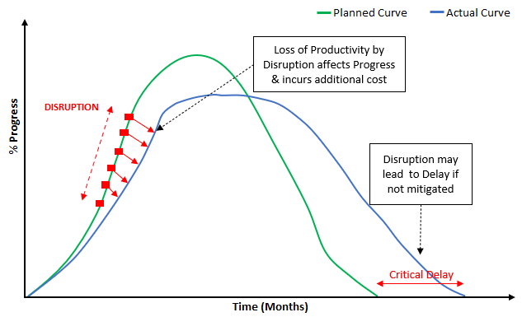  What are the parameters used to measure Disruption?  When labour and equipment costs exceed the planned value, a disruption claim is a plausible solution to recover costs for lost productivity in performing the works. However, it is prudent to consider whether the contractor’s plan (budgeted values) to perform the works was realistic; if flawed, the planned effort cannot be relied upon as a valid yardstick against which to measure effect of disruption. In such circumstances, a comparison between the actual effort required to complete the works when disruption is not present (referred to as the ‘measured mile’) against the actual effort taken to complete the works when those works were negatively affected (i.e., when disruption was present) is likely to be more appropriate. Any disruption claim is challenging to prove without the support of actual records, if absent, any perceived losses on labour or equipment costs may be attributed to the contractor’s own failures to perform the works.  Here, productivity refers to the efficiency level of labour and equipment which can be measured either for labour manhours, equipment plant hours or cost (price per unit). Hence, the failure to keep records for actual hours (or costs) expended to perform the works with reduced productivity could prove detrimental to a disruption claim.  When evaluating delay, the contract terms may provide rules or guidance on methodology and qualifying relevant event(s) which caused delay. On the other hand, for disruption, the contract terms are seldom useful.  In disruption claims, the contractor should provide evidence regarding:  1. The trade/progress of work which was disrupted;  2. Impacted (when disrupted) & unimpacted period(s) on work;  3. Additional manpower (& equipment) expended on disrupted trades;  4. Evaluate the difference between the periods analysed; and  5. The cause (events) which caused disruption to work.  It is therefore of vital importance for the contractor to maintain a site log for works carried out for the duration of the project. It will allow the contractor to measure productivity of works carried out at any given point in time. In such cases, it would be possible for the contractor could take remedial measures whilst being subject to disruption, raise notices of disruption to the employer, or as a last resort make a credible claim to seek disruption costs. It is imperative for the contractor to maintain site records to show how the works were undertaken during impacted and unimpacted periods, and preferably for the whole project period. In summary, the key to any successful disruption claim is records, records and records.  Commonly used methods to measure disruption in construction are;  1. Baseline productivity analysis;  2. Earned value analysis (EVA); and  3. Measured mile analysis.  I discuss methods 2 and 3 in this article.  Recommended Practice Statements on Disruption  The Society of Construction Law Protocol (SCL Protocol) provides useful commentary on disruption as experienced in construction projects:  - “The objective of a disruption analysis is to demonstrate loss of productivity and hence additional loss and expense over and above that which would have been incurred were it not for the disruption events for which the Employer is responsible.”;  - “…is concerned with disturbance, hindrance or interruption to a Contractor’s normal working methods, resulting in lower productivity or efficiency in the execution of particular work activities. Work that is carried out with a lower than reasonably anticipated productivity rate will lead to (a) activity delay; or (b) the need for acceleration; or (c) a combination of both – and therefore, loss and expense.”;  - “When it comes to explaining the cause of disruption, it is often the case that the Contactor will rely upon multiple and intermingled disruption events to explain its loss of productivity and to support its claimed entitlement not loss and expense relating to the impacted work activities.”  The Association for Advancement of Cost Engineering (AACE) International 29R-03’s interpretation of disruption relates to productivity.  - “An interference (action or event) to the orderly progress of a project or activity(ies). Disruption has been described as the effect of change on unchanged work which manifests itself primarily as adverse labor productivity impacts.”  It has been widely accepted that disruption is difficult to establish, substantiate or quantify. However, this is not entirely true and is largely due to the contractor not maintaining proper and sufficient site records. In most cases, disruption is usually not identified or alerted as it occurs, it is only to when the contractor has found a significant difference between its planned and actual labour and plant costs which is unaccounted for by any variations issued by employer or the contractor’s own inefficiencies.  In summary, disruption involves a situation where, as a consequence of events attributable to the employer, the contractor’s labour and plant productivity were substantially reduced, resulting in contractor having to burn additional labour and plant costs to carry out the works.  Legal Background to Disruption  It is likely that disrupted works relate to sub-critical delays which are not part of a critical path analysis (i.e., critical delay) involving with delays to project completion. As a result, securing a time extension claim (EOT) will not help to recover disruption losses associated with the specific sub-critical trades. In simple terms, EOT deals with indirect resources, those which are required for the extended project period while disruption deals with direct resources which worked in a disrupted manner.  The Hudson’s Building and Engineering Construction Contracts states:  - “The distinction between delay and disruption is important, but rarely articulated, and is to an extent a matter of definition. Delay is usually used to mean a delay to the completion date, which presupposes that the activity which was delayed was on the critical path. Disruption to progress may or may not cause a delay to overall completion, depending on whether the activity delayed is on the critical path as explained above, but will result in additional cost where labour or plant is under-utilised as a consequence of the event.”  In the Walter Lilly case , Mr Justice Akenhead suggested three elements which will help support a contractor’s disruption claim.  1. Events which entitle it to loss and expense;  2. Identifying the events which caused disruption; and  3. That disruption caused loss and/or expense to the contractor.  The contractor’s failure to adhere with the notice provisions within the contact can result in rejection of the disruption claim, especially in contracts with time-bar provisions. In Van Oord and another v Allseas UK Ltd case, the disruption claim was rejected wherein the contractor failed to submit notices. However, in Obrascon Huarte SA v Her Majesty’s Attorney General for Gibraltar, the judge did not take an isolated view of the time-bar clause wherein the breach by employer was obvious to him. It is good practice to submit relevant notices to prevent disruption claims being time barred and provides strong evidence that an event had occurred. The consequences of the event could be disputed but the record of the event should never be in question. In addition, the contractor must have a legal entitlement under the contract, i.e., the disruption event must typically have been caused by an act omission or default by the employer.  Proving a Disruption Claim  The causative agents which result in disruption to construction work are numerous. The causes may include irregular work patterns, densely populated workspaces, extended working hours, lack of quality supervision, poor communication between workers, frequently performing out-of-sequence work, delayed responses to request for information (RFIs), shortage or delayed material deliveries, lack of required approved shop drawings, inclusion of varied works, etc. A project may finish on time but may have experienced a reduction in expected labour and equipment productivity. The effect of disruption or the loss of productivity is quantified as the difference between the planned (or actual unimpacted; in case of measured mile approach) rate of production and the actual rate of production in disrupted period.  Earned Value Analysis  The current performance of work can be used to forecast cost or schedule overruns in a project by making use of trend data. The budgeted hours to carry out the activities are compared to the actual manhours spent for the work and progress achieved (work done). As work activities are progressed, manhours are earned against actual manhours which were spent by contractor to achieve this work. In simple terms, the earned value (‘EV’) measures the manhours earned based on work done, while the actual cost (‘AC’) tells us how much was spent to do this work.  The ratio of the two terms will provide us with the cost performance index (‘CPI’). Any work with CPI less than or equal to ‘1’ indicates that actual costs are less than the earned value (positive cost variance) while CPI greater than 1 indicates that value spent is lost (negative cost variance). In the figure below, CPI value of ‘0.86’ implies that for every dollar spent, only US$0.86 was earned, in this case, the cost variance is the delta between EV and CV, i.e., 30 – 35 = 5.  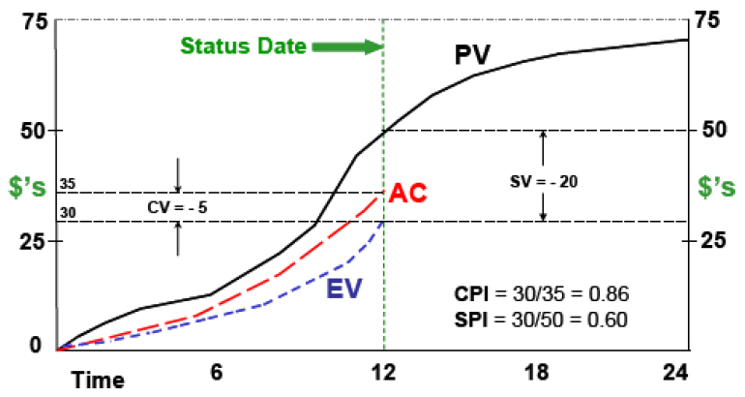  In a real case scenario, the earned value analysis (‘EVA’) must be undertaken as a minimum of four steps which are illustrated with help of the figure below. Here, the green line shows the planned curve (budgeted hours for the excavation works), the golden line is the actual hours burnt to perform the works whereas the blue line is the earned hours based on actual progress achieved for works done. For disruption analysis, the comparison is always between the blue and golden lines and never with the green line which shows the planned effort required to complete this work. The planned curve has no relevance to disruption analysis except to rely on the budgeted hours to arrive at the earned value. The light blue curve shows the cumulative actual progress (basis of earned hours) of the works over a period of time.  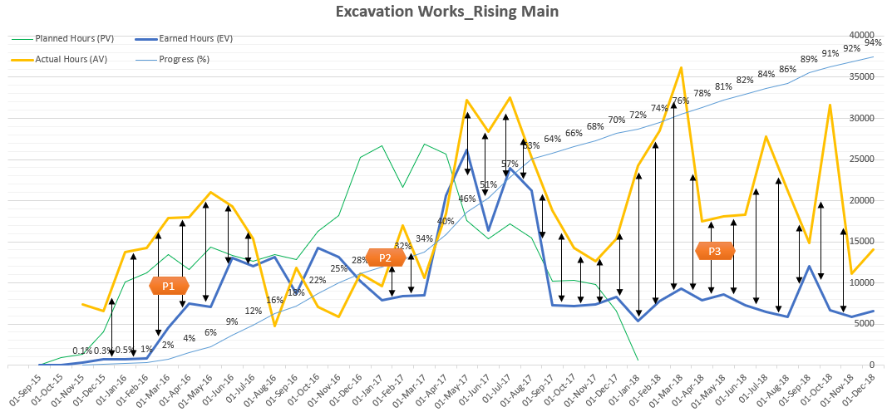  The (first step) is to plot the earned and actual curves for the disrupted trade which must be identified. As can be seen, the two curves lie in same time period, to imply that a direct comparison is possible between what was achieved (earned) and what was spent (actual) to perform the work. The (second step) is to isolate time periods which were likely to be disrupted by a relevant cause(s), i.e., the disruption event. In our case, we have identified three periods (P1, P2, P3), where disruption was in play, i.e., identify periods with delta (gap) between the earned and actual curves. The delta would imply the contractor had to spent actual hours in excess of the earned value to achieve the same quantum of work, i.e., to imply that the contractor had worked in an unproductive manner to perform the works.  The (third step) is to identify events which are likely to have caused disruption within the three time periods. If no such events are available, the disruption is likely to have been caused by contractor issues related to learning curve, unskilled workers, delayed materials resulting in idling manpower or simply because the budgeted manhours were wrong. If events do exist, say for time-period ‘P3’, it is necessary to understand how and why they could or have caused disruption to the works. Also, it is necessary to check if notices were sent to employer citing disruption to the works in ‘P3’, this will help the contractor to assign plausible events to the works which were disrupted in ‘P3’.  The (fourth step) is to determine the delta value between earned and actual curves for ‘P3’. In this context and with the help of reliable records, it should be possible to populate how the actual hours were spent by contractor in this period. Any hours which are solely liable to contractor must be isolated from delta value, say, idling men waiting for correct shop drawings or non-availability of scaffold material. In addition, a suitable factor for inefficient working as per industry standard may also be deducted from the overall disrupted hours. Adopting these steps will help provide a credible earned value analysis to arrive at the true disrupted hours. In most cases, within the contractor’s disruption claim, the effect of disruption is equal to the delta between total planned and actual value, it is easy to see why this could be construed as a global claim devoid of any cause-and-effect argument.  Measured Mile Approach  The measured mile approach involves the comparison of productivity rate achieved for periods when work was not impacted by disruption events (this being the ‘measured mile’) to the productivity rate on identical activities or periods impacted by the disruption events. The ‘measured mile’ calculation is ratio of impacted and unimpacted productivity rates within the same project. It is the preferred approach since it removes the planned (budgeted units) effort (which could be disputed by the parties) from the disruption calculation. However, the approach could be limited when (a) there are no affected area / period or (b) the affected period is too abrupt to provide a reliable measured mile (c) no similar activities exist to allow for a like-for-like comparison and (d) no contractual entitlement to compensation exists.  In Amey LG Ltd v Cumbria County Council, the Judge Stephen Davies noted that:  - “what is referred to as the ‘measured mile’ approach, . . . ought to have been verified by being able to demonstrate that the planned outputs had actually been achieved in some cases where the disrupting events did not occur . . . it ought to have been relatively easy, by reference to the contemporaneous records which were produced, to have conducted a cross check on a suitable sample basis. It seems to me that it would . . . have been a reasonably easy exercise to demonstrate this . . . to undertake an appropriate sampling exercise, which would have ensured that any risk of individual variations would have been picked up and catered for.”  As with the previous method, the first task is to identify the disrupted trade and second task is to plot the actual productivity indices for the work. In the example shown below for piping works, the blue curve shows the cumulative actual progress for the piping works while the golden curve is the productivity index which is calculated as the ratio of actual hours expended to the work output (example, units installed). The dotted golden line is the trend line for the productivity index for the piping works. A low productivity index is proof (though not absolute) of cost overrun to perform the works which could be attributed to various reasons but nevertheless it is not absolute proof of disruption.  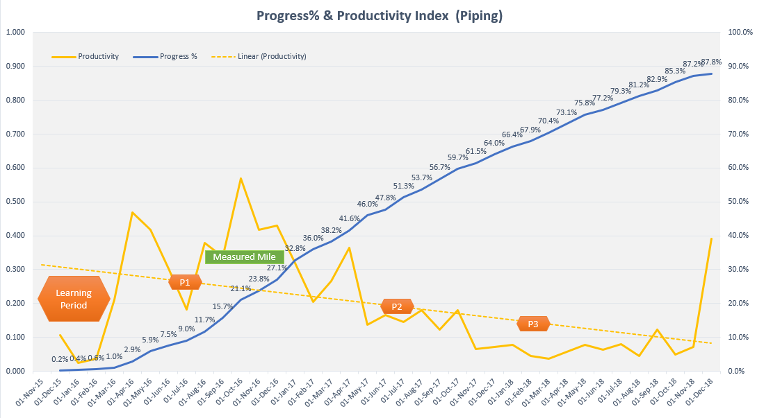  What does the figure tell us about disruption? The portion above the trend line shows periods where productivity for the work was better in relation to other periods which are below the trend line. As is evident, this method does not take into consideration the budgeted hours to arrive at the disrupted hours, rather, it relies solely on actual performance. In this method, the comparison of productivity over periods of time helps to establish periods of time which were likely to have been adversely affected by events. In this case, there are three distinct periods (P1, P2, P3) where productivity falls below the trend line, the initial learning period is ignored. The unimpacted period of performance above the trend line is the ‘measured mile’, which is used as the yardstick to establish what the contractor’s cost performance should-have-been or would-have-been (to establish a base productivity rate). Under the measured mile approach, the entire productivity hours lost within the three periods are in theory claimable based on disruption events which exist in those periods. However, as previously stated there are deductions to be made, firstly, any hours which are solely liable to contractor issues must be segregated and thereafter, a suitable factor must be applied for contractor’s inefficient working.  The measured mile is not always a go-to or adopted method for various reasons. If the contractor has not maintained site records, then establishing a base productivity level will not be possible. Also, if the disruption was severe through the course of the project or works, there may be no undisrupted measured mile to compare with. In other cases, if the works are complicated, there may be no typical section to allow a like-for-like comparison of the productivity levels for the works carried out.  Conclusion  In summary, it is advisable to adopt a rational approach for disruption analysis wherein it is necessary to understand the circumstances surrounding disrupted working and choose a suitable method to evaluate effect of disruption. The two commonly used methods for disruption analysis are earned value analysis and measured mile approach. However, no one size fits all, the right method must inevitably be adopted to illustrate disruption to the works wherein care must be taken to avoid a global approach. In any event, the availability of records to identify disruption events and daily log to measure disrupted manhours is a vital ingredient to any successful disruption claim. Also, the contractor cannot get past the onerous question as to whether it was possible to divert resources (only cost of re-mobilizing resources will be allowed under disruption) and utilize resources in an efficient manner to work elsewhere in areas which were not subject to disruption.  A disruption claim is to retrieve loss of direct hours spent on unproductive interrupted working which results in loss of efficiency and reduced productivity hence, actual data is inevitably required to support this argument. The disruption claim must have a contractual basis, i.e., the disruption event must have been caused by an act omission or default by the employer. The result for a successful disruption claim is almost always an award for disruption costs with no extension of time, unless the event caused critical delay to the completion of the works, which will be determined separately through a suitable form of delay analysis.  About the Author  Pramod Oommen holds a bachelor’s degree in mechanical engineering (B.Tech) and master’s degree in construction law (LLM) with over 20 years of work experience in the construction industry. He has a wealth of knowledge working in commercial buildings, international airports, oil & gas, power plant and other infrastructure projects.  He has worked in contractor and consultant roles in United Arab Emirates, Sultanate of Oman, State of Qatar, Saudi Arabia, Kuwait, Indonesia, and Japan. In the last nine years, he’s worked solely as delay analyst on prolongation and disruption claims. He holds multiple certifications as Project Management Professional (PMP), Planning and Scheduling Professional (PSP), Certified Cost Professional (CCP) and RICS Expert Determiner. Pramod is well versed in most forms of forensic delay analysis techniques and has helped contractor’s win time extension and compensation claims. He is familiar with the Society of Construction Law (SCL) protocols, AACEI recommended practice 29R-03 and FIDIC suite of contracts.

A critical delay is delay to the completion of overall works which drive the project completion date.
The Society of Construction Law founded in 1983 has worked to promote the study and research in the field of construction law and related subjects both in the UK and overseas. (https://www.scl.org.uk/about/history)
SCL Delay & Disruption Protocol - 2nd Edition (Section 18).
SCL Protocol (Section 5.5).
SCL Protocol (Section 18.5).
AACEI is a non-profit organization founded in 1956 at the University of New Hampshire, USA which provides recommended practice (RP) in the construction industry. (https://www.linkedin.com/company/aace-international)
Published on 25 April 2011.
AACEI Recommended Practice No. 10S-90.
Hudson's Building and Engineering Contracts, 13th edition, Chapter 6 - Section 6.15.
Walter Lilly & Company Limited v (1) Giles Patrick Cyril Mackay (2) DMW Developments Limited [2012] EWHC 1773 (TCC).
[2015] EWHC 2074 (TCC).
[2014] EWHC 1028 (TCC).
Disrupted? Prove It! (Fenwick Elliott, Insight Issue, May 2017).
Disruption in construction Projects: How do Courts Measure Damages (by Sarah B Biser, Fox Rothschild, US)
Lukas, J. A. (2012). How to make earned value work on your project. Paper presented at PMI® Global Congress 2012—North America, Vancouver, British Columbia, Canada. Newtown Square, PA: Project Management Institute.
The earned value is estimated by multiplying the actual progress recorded for the activity at any given point in time and the budgeted value units for the work.
Disrupted? Prove It! (Fenwick Elliott, Insight Issue, May 2017).
[2016] EWHC 2946 (TCC).

